Final
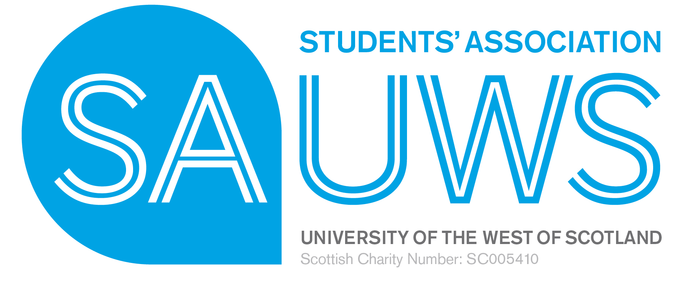 | SAUWS Board Discussion – Lanarkshire Project v1

Note of the meeting 27th January 2017 3.15pm

Members Present
John Black JB President of Education
Johnathan Cranstoun JC President Sports & Wellbeing
Lisa McCusker LMcC President of Student Support
Arlane Fleming AF External Trustee
Allan Miller AM External Trustee
Heather Armstrong HA President of Societies and Citizenship
Sam Robertson SR External Trustee
Mark McRitchie MM External Trustee

In Attendance
Janine Hunt JH SAUWS Chief Executive
Jason Warnock JW Business Development Consultant

Apologies
Martyn Cosh MC Student Trustee

The meeting was called as part of the Board strategy day, to discuss the opportunities posed by the SAUWS involvement in the Lanarkshire Project and the related challenges of the emerging ‘ space brief’ from the project team.

BDC and CEO outlined the paper presented and some of the key questions that have been emerging from the number of meetings in relation to the developing role and remit for members of staff and sabbatical officers. In addition to the recent meetings held with SSR and CEO meeting with the Deputy VP who is Project Sponsor – Paul Martin and Marcus Ross as Project Director.

There had been 13 meetings undertaken in the period of January 2017 with various members of the project team and SAUWS’ representatives. The pace of design and requirements were moving very fast with an absolute deadline of requirements agreed with the project team by 28th February. 2017

The Board identified key issues in relation to potential positioning of SAUWS in building C of the new Eco Campus they were as follows:
- Needing to have a shop positioned with sight line straight on to any potential customer
- That all appropriate branding and signage would identify what was the student and association ‘ zone ‘
- Directional signage would be required.

In response to the question from the Business Development Consultant ( BDC) as to whether SAUWS was positioned in the correct space for the charity (HAA design HAA/873 then the Board decided more information was needed and that an actual space brief needs to be devised to be able to provide the UWS Project Team with clear remit for what we wanted.

The Board noted that this would require dimensions, size of space and an understanding of the range of products that were needed from the mainly student population.

The Board noted that Arlane Fleming offered to meet with Jason to be able to assist in the refinement of what a SAUWS Space Brief would look like.

It went on to discuss its need to better understand the options available in relation to potential operating models afforded by the Lanarkshire Campus Project and also to understand what models of commercial business that this may open up. This work will need to be developed by Jason Warnock – BDC.

Finally the Board agreed that it would be appropriate to explore at a high level what any commercial partnership could be with UWS, as offered by the opportunity that Lanarkshire Project poses. It authorised the BDC and CEO to explore the principles and issues with an opportunity with key UWS commercial staff.

Further deliberations will need to be undertaken when information becomes available.

27.01.17
CEO v 1

Approved 28/04/2017

